**MODULE 6 - CERTIFICATE VERIFICATION**

**Mohit Mande**

**Shivam Garg**

**Geethu**

Hello Mam,

Our group had the following tasks to do written in bold:

**STAGE 1 :**

**USE CASE 1 :**

**INPUT : ENTER CERTIFICATE ID - ALSO KNOWN AS CID**

**SHOW : VERIFIED**

**OUTPUT :**

**INTERN ID**

**NAME**

**EMAIL ID -**

**RESPECTIVE DEPT**

**CERTIFICATE ISSUED DATE (MAJOR/IMPORTANT)**

**STAGE 2 :**

**USE CASE 2 :**

**I/P : ENTER INTERN ID**

**SHOW : VERIFIED**

**OUTPUT :**

**NAME**

**EMAIL ID**

**RESPECTIVE DEPT**

**JOINING DATE**

**STAGE 3 : INTEGRATION OF USE CASE 1 + USE CASE 2**

**NOTE : ONE SINGLE PLATFORM OR APP FOR BOTH USE CASE**

**FEW POINTERS : DATA SHOULD BE IN CSV**

**COLLECT CERTIFICATES**

**4- PYTHON CERT**

**10 - DATA SCIENCE**

**10 - AI**

UPDATE:

**Stage 1:**

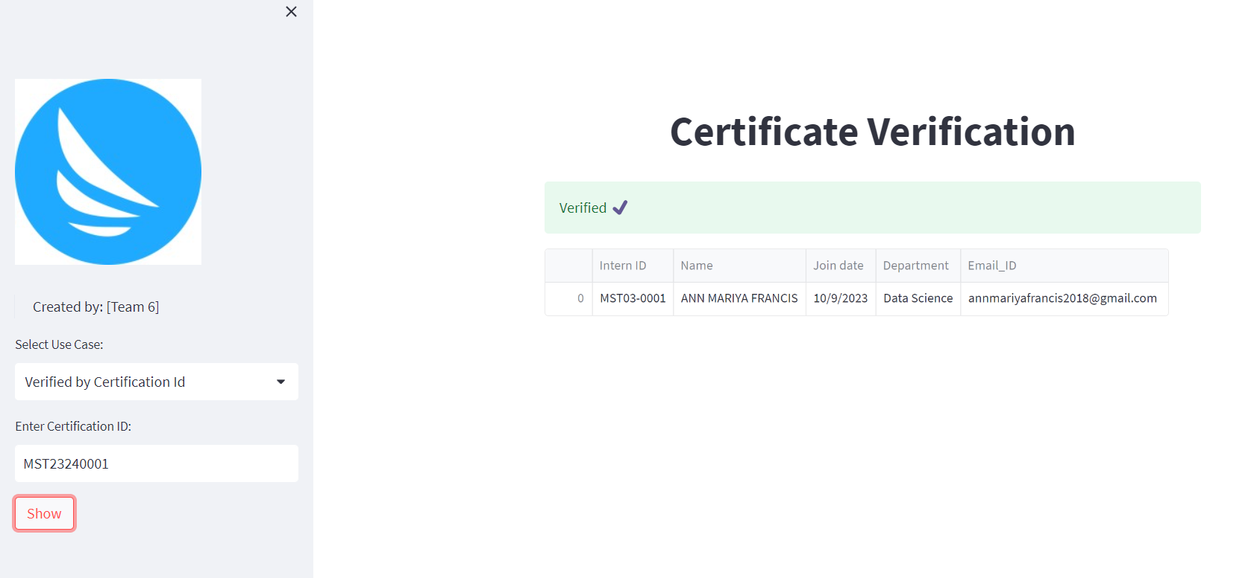

We have done the stage 1 of verifying the intern details using certificate id.

**Stage 2:**

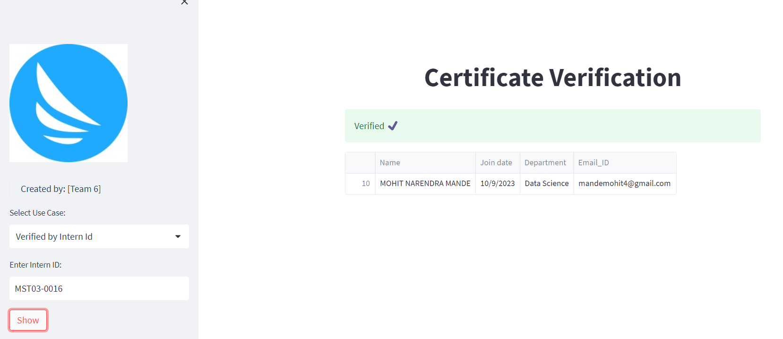

We have also done stage 2 by using intern id and then verifying the intern details.  
  
**Stage 3:**

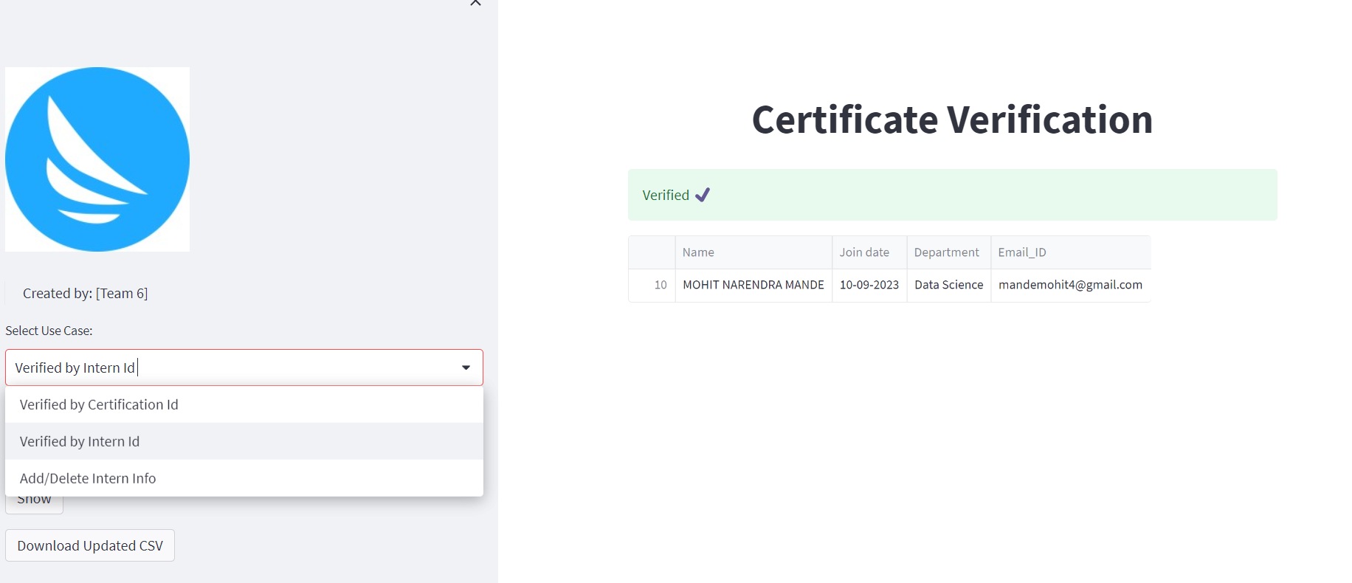

We have also integrated stage 1 and stage 2 on one single platform where you can see both the options:

Verify by intern id

Verify by certificate id

THANKS.